Year 10 Examination Questions

Astronomy

What is a black hole?

(a) A rapidly spinning star which gives out neutrons.
(b) A dark invisible hole in space which is a worm hole into another parallel universe.
(c) A massive explosion which gives out huge amounts of light.
(d) The remains of a star which is so massive that light can not escape from it.

What are galaxies? Select the best answer from the options below.

(a) Huge masses of gas that explode.
(b) Collections of stars and solar systems and gas clouds.
(c) Shining objects in the sky.
(d) A star, along with its planets and their moons.

Which of the following best describes our view of the centre of our galaxy?

(a) We cannot see the centre of the galaxy.
(b) It is a small, bright cluster of stars.
(c) There is a black hole at the centre of our galaxy.
(d) The galactic centre is a faintly luminous cloud of gas and dust.

All known quasars are very far away. This is because quasars ...

(a) happened a long time ago.
(b) were once close by, but have been carried far away from us by the expansion of the Universe.
(c) are nearby but are hidden by clouds of dust and gas.
(d) are often hidden by planets.

A star like our Sun has a life cycle. Each of the lists below contains events from this life cycle. Which list has the events in the correct order?

(a) Nebula, protostar, star, red giant, planetary nebula.
(b) Protostar, planetary nebula, nebula, star, red giant.
(c) Protostar, nebula, red giant, star, planetary nebula.
(d) Nebula, planetary nebula, red giant, protostar, star.

If the light from a star is blue shifted, that tells us that ...

(a) the star must be moving towards us.
(b) the star must be moving away from us.
(c) the star must be moving parallel to us.
(d) the star must have a solar system of planets.

The Universe is expanding. This is usually taken to be evidence that ...

(a) the Universe began in a Big Bang.
(b) we are at the centre of the Universe.
(c) gravity only works near the Earth.
(d) the Universe was created by a Supreme Being.

Stellar parallax occurs because ...

(a) the Earth changes position by 300 million kilometres every six months.
(b) stars travel very fast so they are in different places every time we look.
(c) the Universe is expanding.
(d) sometimes we approach a star, but six months later we move away from it.

A light year is defined as …

(a) the distance light travels from the closest star.
(b) the distance from Alpha Centauri to the sun.
(c) the distance of the Earth from the sun.
(d) the distance light travels in a year.

The main fuel of stars is …

(a) hydrogen.
(b) helium.
(c) carbon.
(d) gold.

Clouds of gas and dust that form spectacular images are _____.

(a) stars.
(b) nebulae.
(c) planets.
(d) suns.

When a star the size of our sun begins to run out of fuel it transforms and swells in size until it becomes a _____.

(a) white dwarf.
(b) red giant.
(c) red dwarf.
(d) white giant.

A star ten times the size of our sun would go through the following stages …

(a) supernovea, neutron star, pulsar, black hole.
(b) pulsar, neutron star, black hole, supernovea.
(c) neutron star, pulsar, supernovea, black hole.
(d) black hole, supernovea, pulsar, neutron star.

The remains of a supernovae form a _____.

(a) red giant.
(b) nebulae.
(c) black hole.
(d) pulsar.

A galaxy is a group of many billions of stars held together by _____.

(a) gravitational forces.
(b) black holes.
(c) magnetic forces.
(d) quasars.

The Milky Way is most accurately described as a _____.

(a) planet.
(b) universe.
(c) solar system.
(d) galaxy.

Most scientists currently favour the theory that the universe …

(a) once fit inside a pinhead before exploding out into a big bang.
(b) has always existed in its current form.
(c) began on a large scale, and is slowly shrinking so that it will one day fit inside a pinhead.
(d) has always existed and is continually expanding and contracting.

The nearest star to the Earth beyond the Sun is Alpha Centauri. Using current space vehicles, approximately how long would it take to reach Alpha Centauri?

(a) 80 000 years.
(b) 8000 years.
(c) 8 light years.
(d) 0.4 light years.

During the nuclear fusion reactions occurring in the Sun's core ...

(a) hydrogen particles join to form helium particles, and energy is absorbed.
(b) helium particles join to form hydrogen particles, and energy is released.
(c) hydrogen particles join to form helium particles, and energy is released.
(d) helium particles join to form hydrogen particles, and energy is absorbed.

In which galaxy is our solar system located?

(a) Andromeda
(b) Sombrero
(c) Milky Way
(d) Whirlpool

Which of the following is false?

(a) The Sun uses a nuclear reaction.
(b) The Sun is the only star in our galaxy.
(c) The Sun is 4.57 billion years old.
(d) The Sun will one day become a red giant.

What type of reaction fuels the vast amount of energy produced by a star?

(a) Nuclear fission
(b) Chemical
(c) Physical
(d) Nuclear fusion

What element is the main fuel for the nuclear reaction that occurs on the surface of a star?

(a) Hydrogen
(b) Helium
(c) Uranium
(d) Carbon

Which of the following statements is correct?

(a) The Sun is the centre of the galaxy.
(b) The universe has reached its mature size.
(c) The universe is constantly changing.
(d) The Milky Way galaxy has a fixed position in space.

What is the most commonly agreed scientific theory for the creation of the universe?

(a) Darwinian evolution
(b) Theory of relativity
(c) Big Bang theory
(d) Multiverse theory

What is the correct scientific notation for one billion?

(a) 1 000 000 000
(b) 1 × 100⁹
(c) 1 × 10⁹
(d) 1000 × 10⁹

Which scientist is credited with the discovery of the equation E = mc².

(a) Albert Einstein
(b) George Gamow
(c) Georges Lemaitre
(d) Ralph Alpher

When was the Big Bang theory proposed?

(a) 1948 by George Gamow and Ralph Alpher
(b) 1933 by Albert Einstein
(c) 1927 by Fred Hoyle
(d) 1927 by Georges Lemaitre

Which of the following is the best definition of a constellation?

(a) A grouping of planets in an apparent pattern
(b) Patterns of stars that change
(c) Stars that are in fixed positions together
(d) A grouping of stars in an apparent pattern

To date, how far away is the most distant object in the known universe?

(a) 61 billion light-years
(b) 10 billion light-years
(c) 51 billion light-years
(d) 15 billion light-years

What are the two major theories about the beginning of the universe?

(a) The Big Bang theory and the Steady State theory
(b) The Big Bang theory and the Galaxy Bulk theory
(c) The Steady State theory and the Arrow of Time theory
(d) The Steady State theory and Darwinian theory

How can we tell that the star Sirius is moving away from us?

(a) The spectrum of the star has shifted towards red frequencies.
(b) The spectrum of the star has shifted towards blue frequencies.
(c) There is less of a gravitational field being emitted by the star.
(d) There is more of a gravitational field being emitted by the star.

What is the key difference between the formation of a supernova and the formation of a white dwarf?

(a) The starting mass of the star
(b) The position in the galaxy
(c) If there are planets in the system
(d) Whether the star was hit by an asteroid

How long ago was the Big Bang?

(a) 15 billion years ago
(b) 10 trillion years ago
(c) 1 billion years ago
(d) 65 million years ago

What does the equation E = mc² describe?

(a) The conversion of matter into energy
(b) The conversion of matter into entropy
(c) The conversion of light into heat energy
(d) The conversion of energy into gravity

What is Hubble’s Law?

(a) The closer a galaxy is, the greater its blue shift and so the faster it is moving away from us.
(b) The further away a galaxy is, the greater its red shift and so the faster it is moving towards us.
(c) The closer a galaxy is, the greater its red shift and so the faster it is moving away from us.
(d) The further away a galaxy is, the greater its red shift and so the faster it is moving away from us.

What do nebulas consist of?

(a) Asteroid belts
(b) Stellar clouds of gas and dusts
(c) Stellar masses of gas and energy
(d) Planets and their magnetic fields

What is the speed of light?

(a) 300 000 m/s
(b) 300 000 000 m/s
(c) 300 000 000 km/s
(d) 3000 km/s

What does the Steady State theory propose?

(a) The universe and the galaxies in it stay in the same place.
(b) The universe has always existed.
(c) The universe remained at the same size after it formed.
(d) The universe maintains the same number of galaxies.

Which of the following is the best definition of a star?

(a) A sphere of mostly hydrogen and helium gas that shines brightly and is held together by gravity
(b) A sphere of mostly helium gas that shines brightly and forms gravity
(c) A sphere of solid hydrogen that shines brightly and is held together by gravity
(d) A sphere of gas that shines brightly and forms gravity

What is a light-year?

(a) The distance light travels in a year (365 days)
(b) The amount of light emitted by the Sun in a year (365 days)
(c) The time it takes light to travel from the Sun to Earth
(d) The distance a planet travels away from the Sun in a year (365 days)

If a planet is 0.5 light-years away from us, what is the distance between the planet and Earth?

(a) 1.5 × 10⁸ km
(b) 4.75 × 10¹² km
(c) 7.0 × 10¹⁷ km
(d) 9.5 × 10¹² km

Section B

Astronomers have found an Earth-like planet orbiting a star called Mu Arae. It takes light 50 years to reach Earth from this star, travelling at 300,000 km/second.

(a) The best speed possible for a spaceship with our current technology is about
50,000 km/h, which is equal to about 15 km/second.

Do you think humankind will be able to get to Mu Arae in a reasonable time?
Give a reason for your answer and support it with a calculation of how long it would take.
(4 marks)

(b) Describe a possible way in which humankind might be able to overcome the vast distances required to travel to nearby galaxies. It may be a theoretical or practical method, but you must give some details about how it might be achieved.
(3 marks)

Stars begin life with the same beginning - a protostar of hydrogen gas forms under gravity and generates heat to start a nuclear reaction. Once formed, it is the size of the star that determines its ultimate pathway to its "death".

(a) Our Sun is an average size, and will continue to produce energy for how many more years?

years
(1 mark)

(b) Describe the stages involved in the lifecycle of a star similar in size to our Sun. Consider the stages once the star has started to produce sustained energy. You must name each stage and give a brief description of what is occuring.
(4 marks)

(c) Very large stars undergo a supernova towards the end of their life.

(i) What is a supernova?
(1 mark)
(ii) Describe what happens to the star to cause the supernova to occur.
(2 mark)

(d) After a supernova, these large stars become black holes. Describe two characteristics of a black hole.

•

•
(2 marks)

(e) Describe one way in which scientists might detect the presence of a black hole in a region of space.
(1 mark)

Below is a diagram showing the spectra for light coming from a star.

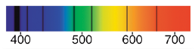

(a) What causes the dark lines in the spectra?
(2 marks)

(b) What is a "blue shift"? Use the diagram to help explain your answer.
(2 marks)

(c) What does your answer to (b) tell astronomers about the movement of a star or galaxy relative to Earth?
(1 mark)

(d) Describe what Edwin Hubble discovered about distant galaxies when he observed the light coming from them.
(2 marks)

There are several theories on the origin of the universe. Each has its merits in explaining the observations made by astronomers on the universe as it appears now.

The currently accepted theory is the Big Bang Theory.

(a) Briefly describe how this theory describes the origin of the universe. Include a description of what was present at the beginning.
(3 marks)

(b) How does Einstein's equation (E = mc²) relate to this theory?
(2 marks)
(c) Describe two pieces of evidence that supports the theory.
(2 marks)
Human Biology

How many non-sex chromosomes are in a normal human zygote?

(a) 46
(b) 44
(c) 23
(d) 22

What is a locus?

(a) The position of a chromosome within the nucleus
(b) The position of a gene on the chromosome
(c) The position of a chromosome in a karyotype
(d) The number of genes that contribute to a particular trait

What is a nucleotide?

(a) A basic unit of a DNA molecule
(b) A form of nucleus found in bacteria
(c) The membrane around the outside of the nucleus
(d) The nucleus of a sex cell

The gene for tongue rolling is a dominant trait, and the allele for it is represented by T. Frances has the genotype Tt and her husband Rohan is also Tt. What is the probability that they will have a child who cannot roll their tongue?

(a) ¾
(b) ½
(c) ¼
(d) 0

Human blood groups are an example of what kind of inheritance pattern?

(a) Co-dominance
(b) Complete dominance
(c) Incomplete dominance
(d) Partial recession

The pedigree diagram below shows how colour blindness is inherited in the family of Heather and Chris.

What is Angela’s genotype?

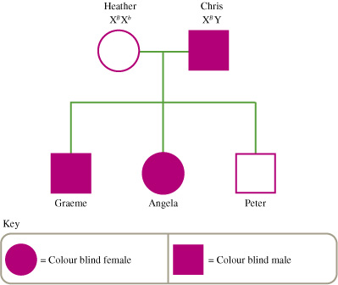

(a) X^{b}Y
(b) X^{B}Y
(c) X^{B}X^{b}
(d) X^{B}X^{B}

How is it possible for two brown-eyed people to have a blue-eyed child?

(a) The parents are both heterozygous for eye colour.
(b) The parents are both homozygous for eye colour.
(c) One of the parents is heterozygous for eye colour while the other is homozygous.
(d) Eye colour is inherited by incomplete dominance.

What term is used to describe the single set of 23 chromosomes contained in the gametes?

(a) Diploid
(b) Haploid
(c) Aneuploid
(d) Tetraploid

What cells are referred to as somatic cells?

(a) Sex cells
(b) Any body cell that is not a sex cell
(c) A body cell that has a nucleus
(d) A body cell that does not have a nucleus

What are the chances that a child will have cystic fibrosis if both parents are carriers for the disease?

(a) 100%
(b) 75%
(c) 50%
(d) 25%

Sex cells are formed using which of the following biological processes?

(a) Mitosis
(b) Budding
(c) Binary fission
(d) Meiosis

How do identical twins occur?

(a) One egg is fertilised by two different sperm.
(b) Two eggs are fertilised by two different sperm.
(c) A zygote splits into two cell clusters.
(d) Two eggs are fertilised by the same sperm.

What branch of science studies the way in which characteristics are passed from one generation of organisms to another?

(a) Anatomy
(b) Mendelism
(c) Genetics
(d) Pathology

During meiosis sometimes genes can be swapped from one chromosome to another homologous chromosome. What is this called?

(a) Transportation
(b) Transcription
(c) Swapping
(d) Crossing over

What term is used to describe matching chromosomes?

(a) Autonomous
(b) Autologous
(c) Heterologous
(d) Homologous

What term means the same as ‘pure-breeding’?

(a) Heterozygous
(b) Homozygous
(c) Hybrid
(d) Dominant

How many chromosomes are there in a human gamete?

(a) 13
(b) 46
(c) 23
(d) 92

If a genetic disorder is described as having an X-linked dominant inheritance, which of the following is TRUE?

(a) A father with the disorder will always pass it on to his sons.
(b) Only girls can have the disorder.
(c) A father with the disorder will always have daughters with the disorder.
(d) A mother with the disorder will always have sons with the disorder.

What is an allele?

(a) An alternative form or expression of a gene
(b) The phenotype expressed by a gene combination
(c) The position of a gene on a chromosome
(d) An inheritable trait

In a pedigree chart, how is a female who shows a specific trait represented?

(a) An unshaded square
(b) An unshaded circle
(c) A shaded square
(d) A shaded circle

The gene that codes for colour in snapdragons has two different alleles: red (R) and white (W). If the colour of a snapdragon is inherited by incomplete dominance, what colour would a snapdragon with the genotype RW be?

(a) Red
(b) Pink
(c) White
(d) Red and white stripes

Where in the cell are chromosomes located?

(a) In the cytosol
(b) In the nucleus
(c) In the vacuoles
(d) In the cell membrane

The table below shows some of the DNA triplets and the amino acids that they code for.

DNA triplet | Amino acid
AAT | Leucine (leu)
ACG | Cysteine (cys)
TAC | Start/methionine (met)
ATT | Stop
CGG | Alanine (ala)
CAT | Valine (val)
ATG | Tyrosine (tyr)
CCA | Glycine (gly)

What sequence of amino acids would be produced by the DNA section CATCGGCCACGG?

(a) Met-ala-tyr-ala
(b) Val-ala-gly-ala
(c) Val-met-gly-ala
(d) Ala-gly-met-cys

Which base binds to thymine?

(a) Thymine
(b) Cytosine
(c) Guanine
(d) Adenine

A particular disorder occurs only in males, and males who have the disorder always pass it to their sons. Where is the gene for the disorder carried?

(a) On the X chromosome
(b) On one of the autosomes
(c) On the Y chromosome
(d) On two of more of the autosomes

In pea plants, the gene for tall stems (T) is dominant over the gene for short stems (t). The phenotype for a pea with the gene combination Tt is:

(a) tall stems.
(b) middle-size stems.
(c) short stems.
(d) TT.

When red flowered snapdragons are crossed with white flowered snapdragons, some of the offspring have pink flowers. This is an example of:

(a) cloning.
(b) incomplete dominance.
(c) karyotyping.
(d) mutation.

It has been suggested that King Henry VIII of England married several women because he was determined to have a son, and his first three wives failed to produce one. His assumption that the fault lay with the women was:

(a) false considering the low survival rate of babies in the 16th century.
(b) true as it is the mother’s egg that determines whether the offspring is a boy or a girl.
(c) reasonable since the health of the mother is very important in determining the sex of the baby.
(d) false since the sex of the baby is determined at conception by the father’s sperm.

An organism is heterozygous for a characteristic if it has:

(a) two genes which are the same.
(b) more than two genes which are the same.
(c) only one gene.
(d) two different genes.

A pure breeding black guinea pig is crossed with a pure breeding white guinea pig. If their first offspring is black, what is the probability that their second offspring is white?

(a) 100%
(b) 50%
(c) 25%
(d) 0%

Which process causes changes in chromosomes to occur?

(a) Cell division.
(b) DNA mutations.
(c) Gene replication.
(d) Reproduction.

In humans, long eyelashes (L) are dominant over short eyelashes (l).
A woman with long eyelashes marries a man with short eyelashes. Two of their four children have short eyelashes. The woman’s genotype must be:

(a) LL
(b) Ll
(c) ll
(d) long eyelashes.

The following punnet square shows the likely result of breeding two heterozygous black guinea pigs. The guinea pigs black colour gene (B) dominates the brown colour gene (b).

b
B

Bb
BB
B

?
Bb
b

The genotype of the offspring in the incomplete square is:

(a) bb.
(b) Bb.
(c) BB.
(d) brown.

The phenotype of the offspring in the incomplete square would be:

(a) black.
(b) black and brown.
(c) black and white.
(d) brown.

Which of the following does not occur during meiosis?

(a) Homologous chromosomes line up along the equator of the cell.
(b) Daughter cells identical to the parent cell are produced.
(c) Chromosomes are doubled but attached at the centromere.
(d) Chromosomes separate and move to the ends of each cell.

During Mendel's genetic experiments, pure-breeding round seed plants were crossed with pure-breeding wrinkled seed plants. The ratio of round to wrinkled seed plants in the F1 generation was:

(a) 1:0
(b) 3:1
(c) 2:1
(d) 1:1

Dogs have 28 chromosomes in their skin cells. How many chromosomes does a haploid dog cell contain?

(a) 14
(b) 28
(c) 1
(d) 56

Long tails are dominant over short tails in mice, and two hybrid mice are crossed. What percentage of the offspring in the F1 generation should have long tails, if this is a monohybrid cross?

(a) 25 %
(b) 75 %
(c) 0 %
(d) 50 %

Inheritance of coat colour in shorthorn cattle is an example of co-dominance. The genotype RR produces a red coat, WW a white coat and RW a roan coloured coat. If a roan cow is crossed with a red bull, what percentage of the offspring would be expected to be red?

(a) 50%
(b) 75%
(c) 25%
(d) 100%

Colour blindness is an X-linked recessive disorder. The symbol for the recessive gene on the X chromosome is X^{n}. The genotype of a colour-blind male is:

(a) X^{n}X^{n}.
(b) X^{n}Y.
(c) X^{n}Y^{n}.
(d) X^{N}Y.

The DNA molecule is a double helix that may be likened to a twisted ladder. The 'rungs' of the DNA ladder are made of:

(a) amino acids.
(b) nitrogen bases.
(c) sugar units.
(d) phosphate units.

Mitosis results in:

(a) four identical cells with half the number of chromosomes as the parent cell.
(b) four identical cells with the same number of chromosomes as the parent cell.
(c) two identical cells with the same number of chromosomes as the parent cell.
(d) two identical cells with half the number of chromosomes as the parent cell.

Although genetic structure determines the characteristics of an organism, some genes may be present but not shown in the physical appearance (that is, recessive genes). The actual physical appearance of the animal is called its:

(a) genotype.
(b) phenotype.
(c) dominant type.
(d) unit character.

Dominant genes mask the presence of _____ genes.

(a) heterozygous
(b) pure-bred
(c) recessive
(d) homozygous

Section B

1. Write the correct number next to each definition.

DEFINITION | NUMBER
Part of the cell containing DNA.
Allele that is masked by another.
Unit of heredity.
Alternatives for a gene.
When there are 2 of the same allele for a particular gene.
There are 46 of these in a human cell.
The genes representing a characteristic.
The physical characteristic shown.
The allele that will mask another.
When there are 2 different alleles for a particular gene.
1. Homozygous
2. Heterozygous
3. Allele
4. Chromosome
5. Gene
6. Recessive
7. Dominant
8. Phenotype
9. Genotype
10. Nucleus

(5 marks)

2. Carefully examine the photo of a young animal (centre) showing the genetic condition called
albinism.

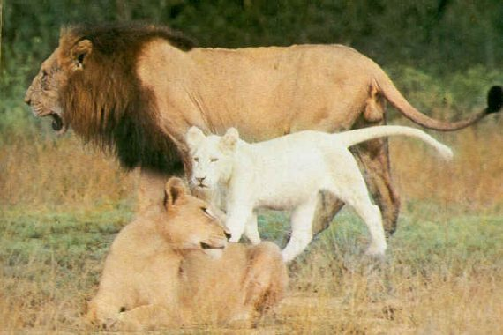

(a) Describe the phenotype of an animal with albinism.

(1 mark)

(b) The young lion cub inherits all its features from its parents. As you can see in the
picture, the lion cub shows the condition but neither of its parents (the male and female
lions in the picture) is albino.

Suggest two reasons that explain why the phenotype for albinism seen in the lion cub is
not visible in either of the lions parents.

(i)

(ii)

(2 marks)

4. The chart below shows the inheritance of a rare (but not serious) blood disorder through four
generations of a family. Individuals with the condition are represented by the shapes that
have been shaded in.

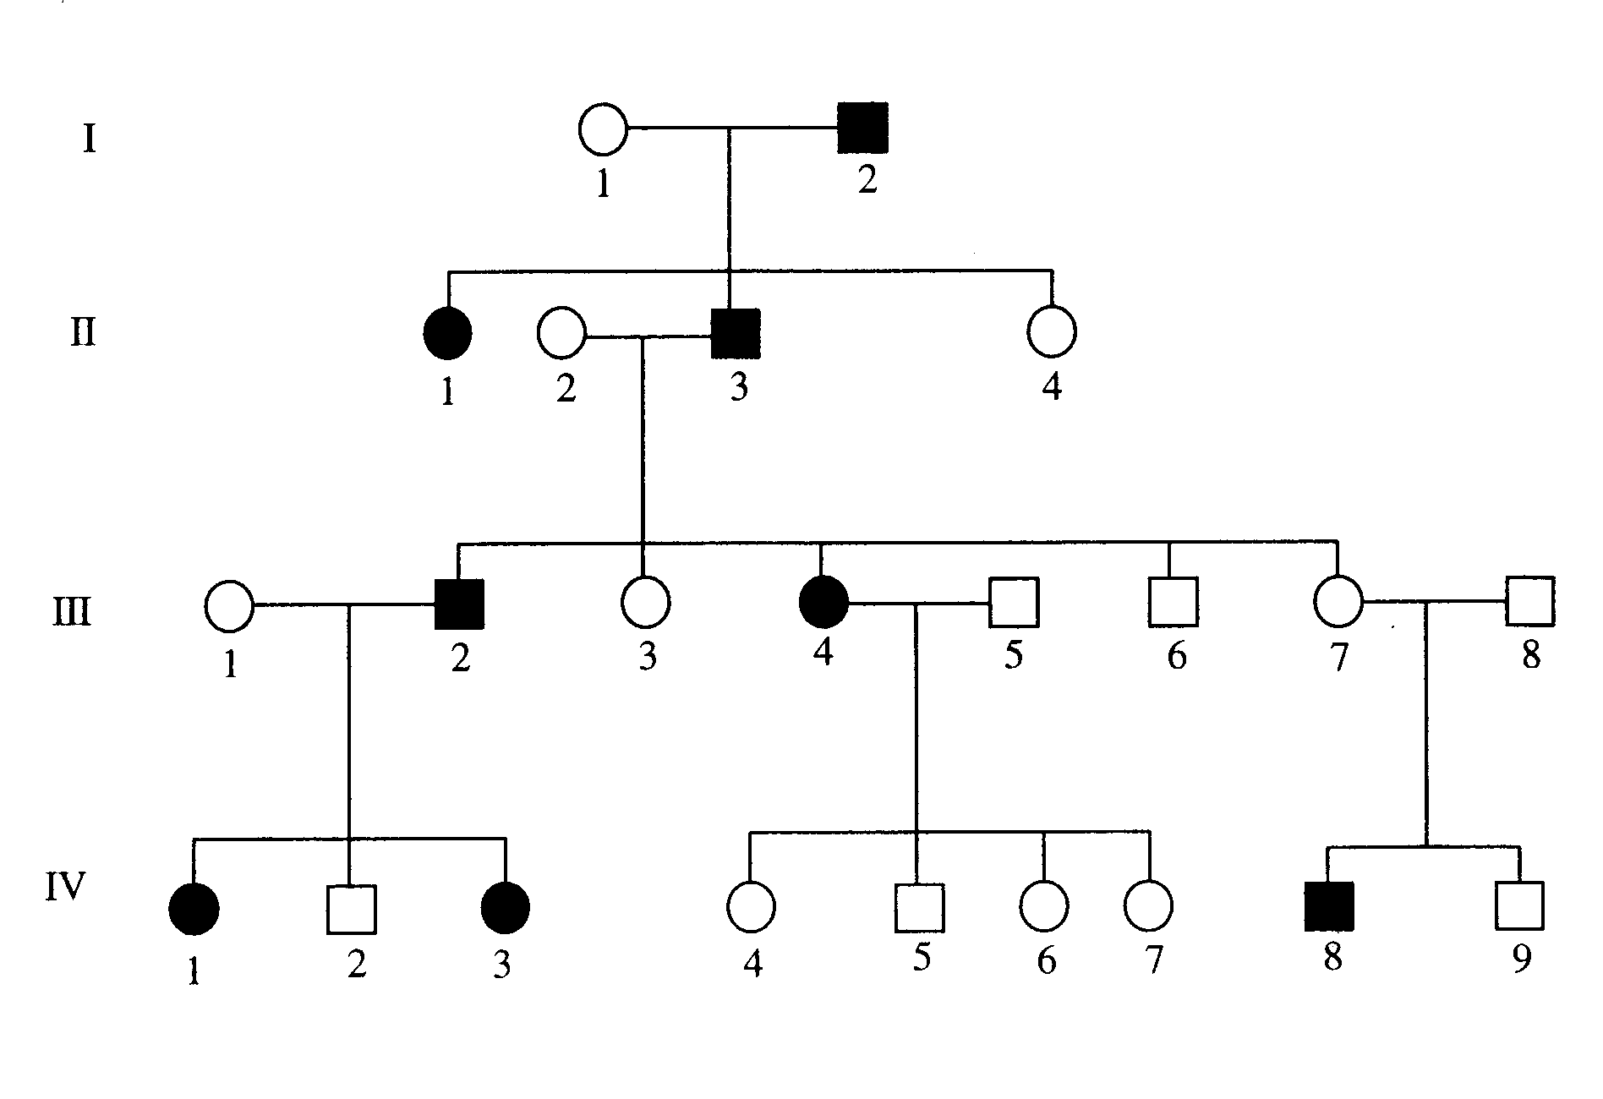

(a) How many people in total show the disorder in this family? (1 mark)

(b) How many of the people with the disorder are female?
(1 mark)

(c) How many children did person II 2 and II 3 have in total?
(1 mark)

(d) Do you think the gene that causes the disorder in this family is controlled by a dominant
gene or a recessive gene? Give one reason from the chart to explain your answer.
(You may need to circle the part used for your explanation.)

(2 marks)

(e) Assume the dominant gene for the disorder is D, and the recessive gene is d.

Give the genotype for the following individuals.

II 2 III 3 III 7 IV 8

(4 marks)
5. In guinea pigs, rough coat is dominant to smooth coat. Two hybrid rough coated
guinea pigs are mated. Determine the genotype and phenotype of the possible offspring.
Include percentages to show the probabilities. Show all of your working.

(4 marks)

6. In snapdragon flowers, red colour is incompletely dominant to white colour. Heterozygous
plants produce pink flowers.

(a) Describe the genotype and phenotype of possible flower colours if a pink snapdragon is
crossed with a white snapdragon. Include the ratios and show all of your working.

(4 marks)
(b) In some plants, flowers show co-dominance. For example, crossing a red flower with a
white flower produces red flowers with white parts, or vice versa. Explain how co-
dominance is different to incomplete dominance.

(2 marks)

7. Mitosis and meiosis are both types of cell division that occur in humans and other organisms.

(a) In the table below outline the differences between the two. Use humans as the
example.

 | Where does this process occur? | How many cells are produced? | How many chromosomes are there in each cell.
Meiosis

Mitosis

(3 marks)

The diagrams below show various stages of mitosis. They are in a jumbled order.

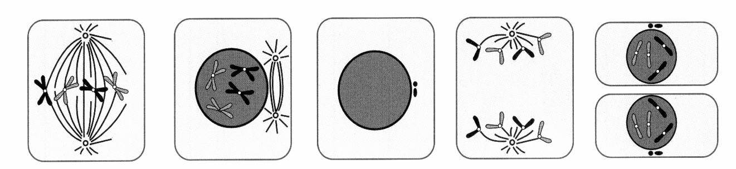

(b) Underneath each diagram write the correct name of the phase. (5 marks)

(c) Complete the below table by explaining the major events occurring in each phase.

STAGE | MAJOR EVENT

(5 marks)

8. (a) Who determines the sex of any children born into a family - the father or mother? Give
a reason for your answer.

(2 marks)
(b) A family has three girls born over five years and the mother is pregnant with a fourth
child. What is the chance of the unborn child being a female?

Justify your answer by setting out a genetics calculation using a Punnett square.

(4 marks)
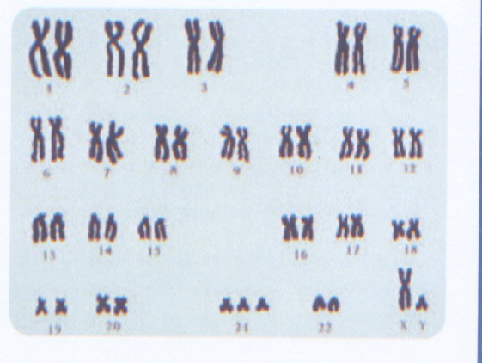
9. A newborn baby shows distinct facial abnormalities. A
karyotype was prepared to determine whether there were
any chromosomal abnormalities. The karyotype is shown
to the right.

(a) What is the total number of chromosomes shown?

(1 mark)

(b) Is the child male or female? How do you know?

(2 marks)

(c) As the geneticist, what would you advise the parents about the health of their baby?

(2 marks)

Section C

SECTION 3 COMPREHENSION (10 marks)

Read the article and then answer the questions that follow. Write your answers in the spaces provided.

Mutation

A mutation is a change in a gene or chromosome in a cell that can be passed on to daughter cells produced by mitosis or meiosis of this cell. Mutation is the process by which a gene (or chromosome) changes structurally and therefore the phenotype changes as a result. Without mutation and the alleles it produces, the biological diversity that exists today would not have evolved.

Mutations, put simply, are the permanent alterations in a cell’s DNA that affect the nucleotide sequence of one or more genes. They can be helpful or harmful to a species, but are usually harmful. The simplest is a point mutation, the change in a single nucleotide. Mutations are most likely to involve cells undergoing cell division. A single cell, a group of cells, or an entire individual may be affected. An entire individual may be affected if mutations occur during meiosis or early in development. For example, a mutation that affects a gamete will be inherited by a child of that individual.

The rate of gene mutation is low. However, as each individual has a large number of genes, mutations are constantly occurring within a species. The rate at which mutations occur can be increased through exposure to mutagens such as radiation, chemicals or temperatures above the normal range for the organism.

Variation and evolution

Mutation ultimately provides genetic diversity; this is the raw material of evolution. Mutation rates are usually very low and, even if different alleles mutate at different rates, this by itself will not lead to rapid changes in populations.

Why would a diploid organism take a random sample of its DNA and combine it with a random
sample of someone else’s DNA to produce offspring? The asexual way of life seems like an efficient way to reproduce yourself. What is the evolutionary benefit to organisms to develop sexual processes? Why is it better to combine the gametes of two individuals to produce a new generation of offspring?

Sexual reproduction allows for the provision of much more variation in organisms. Not only is just
half the genome of an individual passed on to every organism produced sexually, but that half is a random jumble, which may provide some advantage to the offspring. A sexual organism can achieve a significant amount of variation through recombination of DNA and fertilisation. In a changing environment a sexually reproducing organism increases the likelihood that it will adapt to changes that occur.

A haploid asexual organism accrues mutations as they occur over time in an individual. A sexually reproducing organism can combine several beneficial mutations in each generation by recombination and fertilisation. Therefore, sexually reproducing organisms can adapt at a much more rapid rate than asexually reproducing organisms.

Sexually reproducing organisms can eliminate harmful mutations each generation by either forming recombined offspring that are relatively free of mutation, or by producing offspring with many detrimental mutations that then die, removing the harmful mutations from the population.

1. What does the term "mutation" mean in genetics?

(2 marks)

2. What process has relied upon mutations to produce diversity and variation within a
population?

(1 mark)

3. When might a mutation affect an entire individual?

(2 marks)

4. How is the rate of mutations within the population increased?

(2 marks)

5. What provides genetic diversity within a population?

(1 mark)
6. Give two benefits of sexual reproduction within a population.

•

•

(2 marks)

